Welcome to Our World! HAYMAKER was founded for fans who value superior sound above all else. True to its name, HAYMAKER products are modernly designed with cutting edge technology ensuring an aggressive and uncompromising listening experience. Headphones from Haymaker will be the only headphones you’ll ever need.

ABOUT HAYMAKER
HAYMAKER is owned by Peak Audio LLC, a company founded by Matt Bremyer. HAYMAKER focuses on building products that our customers love, by building in features that allow users to custom tailor their headphones to their liking. HAYMAKER also focuses on delivering products that are worth the spend. All systems are designed by HAYMAKER and feature premium materials, giving fans systems that will last and stay in excellent working condition for the life of the product. For more information on Haymaker, please visit The-Haymaker.com.

THE MAN BEHIND THE BRAND
Meet Matt Bremyer. He is the man behind the HAYMAKER brand.

Since childhood, Matt has had a passion for building things - from custom cars, motorcycles, and helmets, to headphones, and more. In 2010, Matt decided that “enough was enough” when it came to premium headphones. He wanted a pair of headphones that not only looked great, but that sounded great too. So, he took matters into his own hands, and from there, HAYMAKER was born. When Matt’s not designing headphones, he can be found enjoying extreme sports and the outdoors.

“THE HAYMAKER” HEADPHONES
Looking for a pair of badass headphones that not only look cool, but sound phenomenal? Enter “The Haymaker” headphones. Designed for fitness junkies, gamers, and more, The Haymaker levels-up the playing field. With a sleek and premium design, The Haymaker offers innovative features such as dual mode adaptive noise canceling, touch sensor controls, hi-resolution ultra high definition surround sound, customizable LED lights, Bluetooth connectivity, clear voice processing, and so much more! They will be available in Summer 2019.

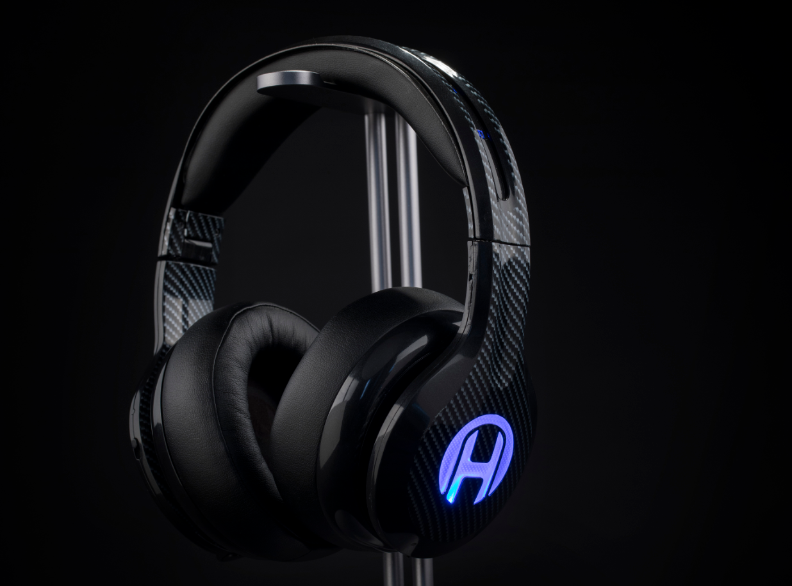

CONNECT WITH US
Facebook: @TheHaymakerHDPH
Instagram: @haymakerhdph

For more information about Haymaker, press releases, images and more, please contact Haymaker@coynepr.com.

